SW Engineering CSC648/848

UMA*Me*

Section 04 | Team 03

MILESTONE 3

| **NAME** | **ROLE** |
| --- | --- |
| Khalid Mehtab Khan | Team Leader |
| Renee Sewak | Scrum Master |
| Anish Khadka | Front End Lead |
| Dat Vo | Backend Lead |
| Jacob Perez | Github Master |

Section: 04 Team: 03 Date: October 30, 2023 Members Present: Khalid, Dat,

Renee, Jacob,

Anish

**APPENDIX I**

1. **UI Functionality & Feedback (Presentation on 10/30)**

| **Instructor’s Feedback** | **Our Plan to Implement or Deny** |
| --- | --- |
| * Improve color palette/scheme of our UMAMe   + The design looks a little too simple and plain. * There can be confusion with the amount of icon buttons we have on our home page. As of now, each recipe on the home page will display a like, comment, share, bookmark, and cooking mode button. Combined with our navigation bar that has 4 additional buttons, it can look cluttered. * For adding a recipe/a quick post, the user could get confused about what the difference is. What does it mean to add a quick post and what does it mean to add a recipe?      * As mentioned earlier, our homepage is a bit cluttered. It can get confusing as there is a lot of text happening. We should organize the homepage so it is more visually pleasing. | We completely agree! In Japanese, Umami means “essence of deliciousness.” Since our software is a twist on a Japanese word, we want to incorporate colors associated with Japanese culture. Red is heavily associated with the culture, so we plan on using a palette associated with red/brown. We want the software to have a welcoming warm tone.  After our M3 presentation, our group talked about the professor’s feedback and completely agreed. What was important was creating priorities when it came to the button. Some are more important than others. As of now, we are still deciding on how the homepage will look, but we do agree that some of the buttons can be eliminated from the recipe cards. What we decided on is embedding the like, comment, share, and cooking mode buttons in each of the recipes instead of displaying them on the homepage. The home page will include recipe cards that have an image, the title of the recipe, and a short comment, but once you click the recipe, the other buttons will present themselves along with the ingredients and instructions. This way, we can include all the functionality of the buttons without overcrowding the homepage.  Our team sees where the confusion can be. That’s why we are considering a small caption near the button that explains what each button means. Another option is once one of the buttons is clicked, the UI will display the functionality.  The breakdown is the +Recipe is meant for intricate and longer recipes that include a step-by-step detail while the quick post is something similar to a quick tweet on Twitter or a quick post on Facebook. Users can add a quick post about a meal they really enjoyed or an image of a new recipe without having to get into the nitty-gritty of adding the recipe. However, if the individual does want to share the recipe, this is where “add recipe” will come into play.  We plan to eliminate confusion by including the meaning behind each function/button by detailing what each button does.  Agreed! Our homepage is not finalized. Up until M3, we have been focusing more on functionality than aesthetics; but we completely agree that the homepage can look cluttered. As of now, we have a few ways to eliminate this:   1. Creating an accordion-style layout that will display the recipe’s name and the user with a dropdown of ingredients/instructions 2. Creating recipe cards on the homepage that display the recipe’s name and an image uploaded by the user of the dish. This option will add more visuals to our page.   ​​ |

1. **P1 Features Committed for Delivery**

Once committed to these features, we cannot change

1. Login/Sign Up

Upon reaching the site, the user will either be allowed to view recipes on guest mode or log in/sign up to bookmark, like, comment, etc. We want users to see the benefit of signing up on UMAMe. That’s why guest mode was important. It allows users to see all the unique and tailorable recipes UMAMe and its users have to offer.

1. Post

Users with an account can post their own recipes. The user will be prompted to answer questions:

1. What is the name of your recipe?
2. What are the ingredients?
3. What are the steps?
4. Would you like to add any tags?

Our Post feature allows users to go as in-depth as they need. From the specificity of their measurements to the duration of the step, the poster can explain the best way to create the dish. If users want to post a quick post - almost like a quick tweet - they can use the “quick post” feature which allows them to post a quick post or image of a dish without having to get into the nitty-gritty of posting a recipe.

1. Complexity Bar

Tying into our post, one of our unique features is what we call the ‘complexity bar.’ Too often, individuals would find a recipe online, and attempt to cook it - only to find out that the recipe is either too complex or time-consuming.

We suggest introducing a 'complexity bar' on each recipe page. With just a quick glance, users can gauge the complexity of a given recipe. The way we plan to implement this feature is through the post feature. Once a user posts their recipe, they will be prompted with a bar that allows them to scale how difficult the recipe is. This way, recipe creators can gauge how complex a recipe is before attempting to recreate it.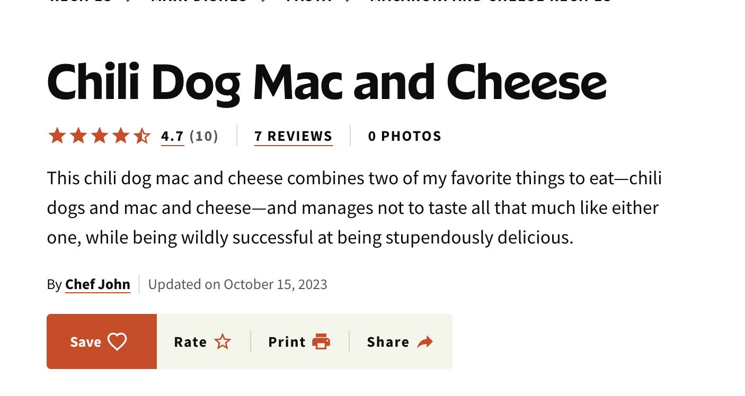

Allrecipes.com

Allrecipes.com is a common recipe site. Here is a visual of what their recipe looks like. Although there is a favorite section, there is no way a user can gauge how complex the recipe can be.

1. Cooking Mode

Cooking mode is a unique UMAMe feature that clears the display for easy-to-read instructions. Cooking can get overwhelming; some individuals have a hard time following instructions. When users are presented with an overwhelming/crowded UI, the design will often steer them away from the site. Cooking mode will allow users to read instructions one at a time.

This feature is an important one; it creates a more inclusive environment. We want users to be able to appreciate our user-friendly design by enabling their ‘cooking mode’ to simplify the instructions of the recipe.

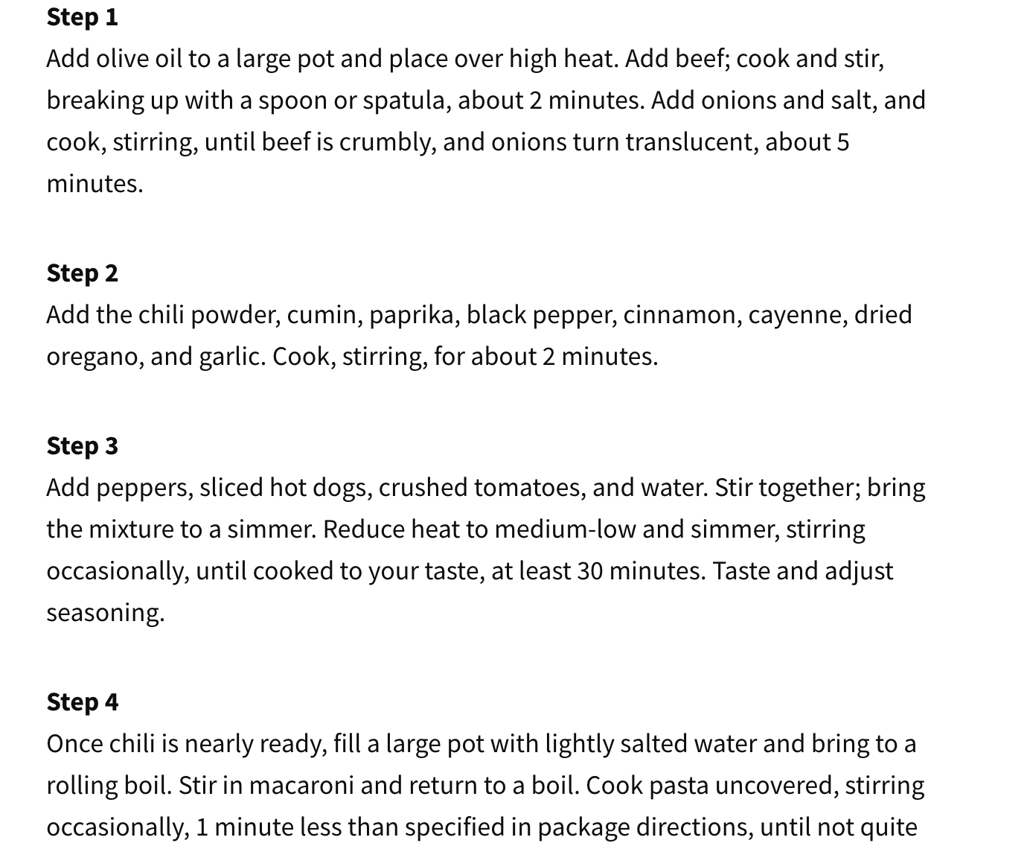

Here is an example of allrecipes.com ’s instructions for a recipe. UMAMe will allow users to simplify the recipe and instead of looking at them all at once by using cooking mode. Additionally, cooking mode would allow for interactive icons like a timer so the user does not have to resort to using an external timer; instead, they will have the luxury of using a built-in timer.

1. Ingredient Mixer

We look for recipes for multiple reasons. Either we want to try something new or maybe we are limited in terms of the ingredients we have readily available at home. However, not a lot of competitor apps cater to the latter category of individuals.

Our unique feature, the Ingredient Mixer, will allow users to make recipes based on what they currently have. We will implement this by allowing the user to select certain ingredient tags. Based on the ingredients the user selects, the application will suggest a recipe for the user to make. This feature prevents users from having to go through every recipe to see if they have sufficient ingredients to cook the meal. The app will instead present the best recipe given what the user has.

1. Collection/Bookmark

Account holders of UMAMe will be able to bookmark recipes! This is a UMAMe-unique feature that we haven’t seen on competitors’ pages. By bookmarking recipes, users can make collections that allow them to group recipes together; whether it be “recipes to try” to “breakfast ideas,” users can be assured that their favorite recipes (or recipes they plan to try) will be safely bookmarked for their reference.

At the end of each recipe, the user will be presented with a set of icons. Sharing, liking, and commenting are common features. However, our cooking mode (represented by the fridge) and the bookmark are unique to UMAMe. The bookmark icon will allow users to keep their wanted recipes grouped together to refer to. This feature will, in turn, have users revisit UMAMe.

1. **Project Status**

Risks: all actual risks (schedule, teamwork, technical, skills, etc.)

RISKS:

Schedule: Due to interfering schedules, it is difficult for us to all meet at the same time.

Solution: We plan to meet multiple times a week outside of our in-class meeting. Wednesday afternoons allow our back-end team to meet and Mondays before class allow our front-end team members to meet. However, we encourage the entire team to attend the meetings when possible

Technical: Our team isn’t fully comfortable with certain areas of our project. For example, some are more comfortable with the backend while others are more comfortable with the front end. This causes issues, however, when a member is sick or cannot attend to their tasks

Solution: During our meetings, we have members individually talk about what it is that they have accomplished since the last meeting. That way, if a team member has any questions regarding the code that was pushed or anything for that matter, the individual can educate them on the matter. The more questions we ask in our meetings, the better we understand all project areas.